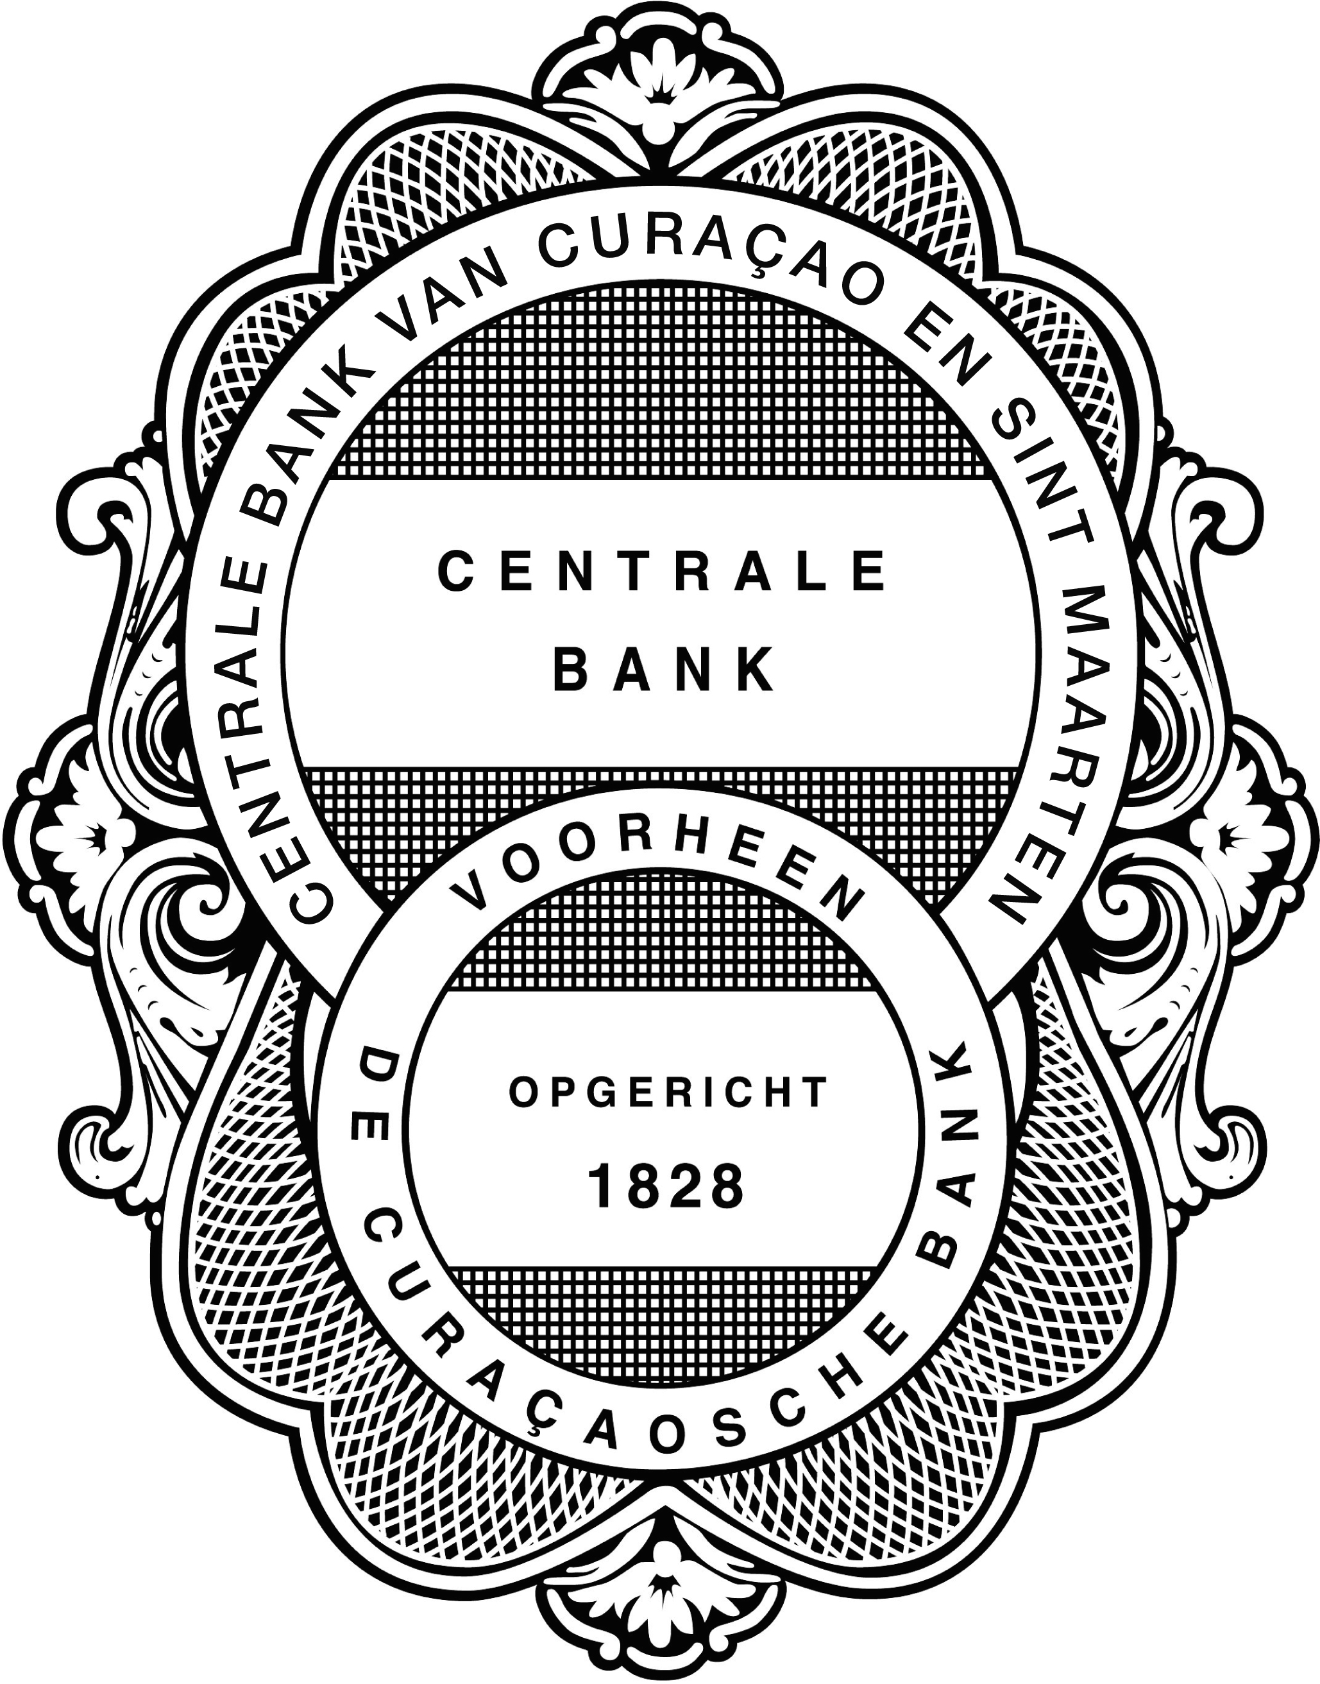 CENTRALE BANK VAN CURAÇAO EN
SINT MAARTEN

(CENTRAL BANK)

TRUST SERVICE PROVIDERS’
SUPERVISORY QUESTIONNAIRE
for Natural Persons

Supervisory Questionnaire as of January 1, 20….

For:_________________________(Name of trust service provider being a natural person)

Purpose
The purpose of this Trust Service Providers’ Supervisory Questionnaire (hereafter “questionnaire”) is to:
- evaluate the adequacy of procedures and controls in place at a trust service provider being a natural person;
- assess the natural person’s compliance with the stipulations in articles 11, 12 and 16 of the National Ordinance on the Supervision of Trust Service Providers (N.G. 2003, no. 114) (the ‘NOST’); and
- evaluate the natural person’s compliance with the directives and guidelines issued by the Bank and the various Anti-Money Laundering rules and regulations in force.

The questions are formulated in such a manner that they may be answered “Yes”, if the procedure or control is adequate and “No” if that is not the case. In the event that a particular question does not apply, this should be clearly indicated in the not applicable (“N/A”) column. Where necessary, explanations should be given in the “Comments” column or included in a separate annex. Note that all questions answered with a “No” or “N/A” should be commented on in the last column. There are, however, some “Yes” responses that may need further clarification. In those instances the space provided in the column “Comments” should be used. If the space is not sufficient, a separate annex should be used.

The questionnaire is considered by the Bank to be an integral part of the annual reporting requirement as stipulated in article 16 of the NOST. The questionnaire must be completed by all supervised trust service providers being natural persons and must subsequently be reviewed by the external auditor. In the event the natural person has been granted a license by the Bank (as opposed to a dispensation), no separate questionnaire must be completed by the person(s) that provide trust services under the responsibility of the natural person. In this particular case, the answers given in this questionnaire must encompass also the operation of the person(s) placed on either Exhibit A or B to the license of a the natural person.

The completed questionnaire must be accompanied by a certified declaration of the external auditor. This declaration must certify the correctness and completeness of the answers given to the questions in this questionnaire. In addition, the auditor should also certify the completeness of the clients’ files as required in the Compliance Check Client Files for Trust Service Providers issued by the Bank. These guidelines are attached to this questionnaire.
Experts accepted by the Bank to certify this questionnaire are:
  - Registered Auditor (RA);
  - Certified Public Accountant (CPA) / Chartered Accountant (CA); and
  - Accountant Administration Consultant with certifying qualifications.

The natural person providing trust services must sign the questionnaire on this page (page 3) and initialize each individual page for identification purposes.

The set up of the questionnaire is as follows:

A. General:
Provision of trust services

B. Administrative Organization, Integrity and Anti-Money Laundering (“AML”) & Combating the Financing of Terrorism (“CFT”) (articles 11 and 12 of the NOST):
- General Policy/ Rule of Conduct
- Procedures relative to Incidents
- Procedures relative to Record Keeping and Client Acceptance
- International Company’s Funds
- International Company’s Administration
- Policy Statement
- KYC – New Customer
- KYC – Data Access/Mining
- Transaction Monitoring/Tracking
- AML & CFT Reporting

For any questions you may have, please contact the Bank’s Investment Institutions and Trust Supervision Department at: 434-5619.

This Trust Service Providers’ Supervisory Questionnaire was completed by:

Name of natural person providing trust services:_____________________________

Telephone number:____________________________________________________

E-mail address:_______________________________________________________

Signature: ___________________________ Date and place: ____________________

Report of Factual Findings
Your ref
Our ref: | ref number
Contact
Client name being natural person
Curaçao/ Sint Maarten
We have performed the procedures agreed with you and enumerated below with respect to your completed and signed Trust Service Providers’ Supervisory Questionnaire dated December 31, 20xx (hereafter referred to as “Regulatory Filing”). We have included this Regulatory Filing, initialed for identification purposes, as an attachment to this report. The completion of this Regulatory Filing is your responsibility. The procedures were performed by us solely to assist you in assessing your compliance with the relevant stipulations in the National Ordinance on the Supervision of Trust Service Providers, and are summarized as follows:
- We obtained the Regulatory Filing from you and, with respect to the answers contained therein, made inquiries and reviewed supporting information on a limited basis to the extent considered necessary.

- We obtained a list from you of your locally established clients (“buitengaatse ondernemingen”). From the list provided to us, we selected and requested xx client files from you, and performed procedures to verify if the files contain the documentation as mentioned in the Compliance Check Client Files for Trust Service Providers issued by the Central Bank of Curaçao and Sint Maarten.

We report our findings below:
- With respect to item 1, nothing came to our attention to make us believe that the answers provided in the Regulatory Filing are not consistent with the explanations and information provided to us, except for the items mentioned below:
- xxxxxxxxxxx
- With respect to item 2 we found that the selected xx client files contain the documentation as mentioned in the Compliance Check Client Files for Trust Service Providers issued by the Central Bank of Curaçao and Sint Maarten, with the following exceptions:
- xxxxxxxxxxx

Because the above-mentioned procedures do not constitute neither an audit nor a review made in accordance with International Standards on Auditing or International Standards on Review Engagements, we do not express any assurance on the Regulatory Filing.

Had we performed additional procedures or had we performed an audit or review in accordance with International Standards on Auditing or International Standards on Review Engagements, other matters might have come to our attention that would have been reported to you.

Our report is intended solely for your information and the Central Bank of Curaçao and Sint Maarten for the purpose set forth in the first paragraph of this report, and is not to be used for any other purpose or to be distributed to any other parties. This report relates only to the items specified above and does not extend to any financial statements.

External auditor

Curaçao/ Sint Maarten

Date of report
Enclosure: Regulatory Filing
Findings from compliance check
Initial for identification purposes:

Question | Yes | No | N/A |  | Comments
- General

A.1. Have there been any changes in your operation/situation since the issuance of the dispensation or license by the Bank or your last questionnaire if this one is not your first?

A.2 If the answer to I.1 is “Yes”, have these changes influenced your operations to such extent that the Bank should re-evaluate its decision with regard to the dispensation or license granted to you ?
Please comment.

Only applicable to natural persons with a license:
A.3 Are all trust service providers that provide trust services under your responsibility mentioned on either Exhibit A or B to the license?

Only applicable to natural persons with a license:
A.4 Are there copies of documentation proving the identity of the persons (including the directors and UBO’s of Exhibit A persons) that provide services under your responsibility available? (see I.3)

Only applicable to natural persons with legal persons listed on Exhibit A to their license:
A.5 Have you concluded a written agreement with the legal person(s) listed on Exhibit A to your license reflecting the fact that the legal person(s) provide(s) trust services under your responsibility?
Only applicable to natural persons with individuals listed on Exhibit B to their license:
A.6 Have you concluded a written agreement with the individual(s) listed on Exhibit B to your license reflecting the fact that the individual(s) provide(s) trust services under your responsibility?

B. Administrative Organization, Integrity and Anti-Money Laundering & Combating the Financing of Terrorism

B.1 Procedure client acceptance and file creation: Do you observe the legal requirements as stipulated in the NOST, LID and MOT?

B.2 Have the procedures relative to question B.1 been documented? Please describe these in an annex.

B.3 Is there a Policy Statement available containing the provisions referred to in the AML & CFT Provisions and Guidelines issued by the Bank?

B.4 Do the client files contain the information as required in the Bank’s ‘Compliance Check Client Files for Trust Service Providers’ guidelines?

B.5 Have you made it a policy not to accept a client or provide services if the subject international company is not willing to provide the information as required in the guidelines mentioned under B.4 above?

B.6 Are you adhering to the record keeping requirements stipulated in the LID, MOT and the AML & CFT Provisions and Guidelines issued by the Bank, including the requirements relative to files of clients with whom the service relation has been terminated?

B.7 Do you at all times segregate/ safeguard the funds or interests of the international companies from your own assets?
B.8 Do you have measures in place to guarantee the preparation of reliable financial figures for the international companies you service?

B.9 When the administration of the international company is not conducted by you, do you receive (audited) financial statements from these international companies?

B.10 Are you able to guarantee prompt and accurate retrieval of the information on your clients, as required under article 12, paragraph 1 of the NOST?

B.11 Are you authorized to conduct transactions on your clients’ bank account? If “yes”, under which circumstances/conditions?

B.12 As the person responsible for compliance, are your responsibilities relative to compliance documented and signed?

B.13 Have you received training in the area of money laundering prevention and detection measures over the last year? If “yes”, who provided the training?

B.14 In case any of your clients is identified by a number or have numbered bank accounts, is the UBO of your client known to you?

B.15 Are there tools available to identify and monitor unusual transactions in a timely manner?

B.16 Have you reported any unusual transactions to the MOT during the last 12 months?

