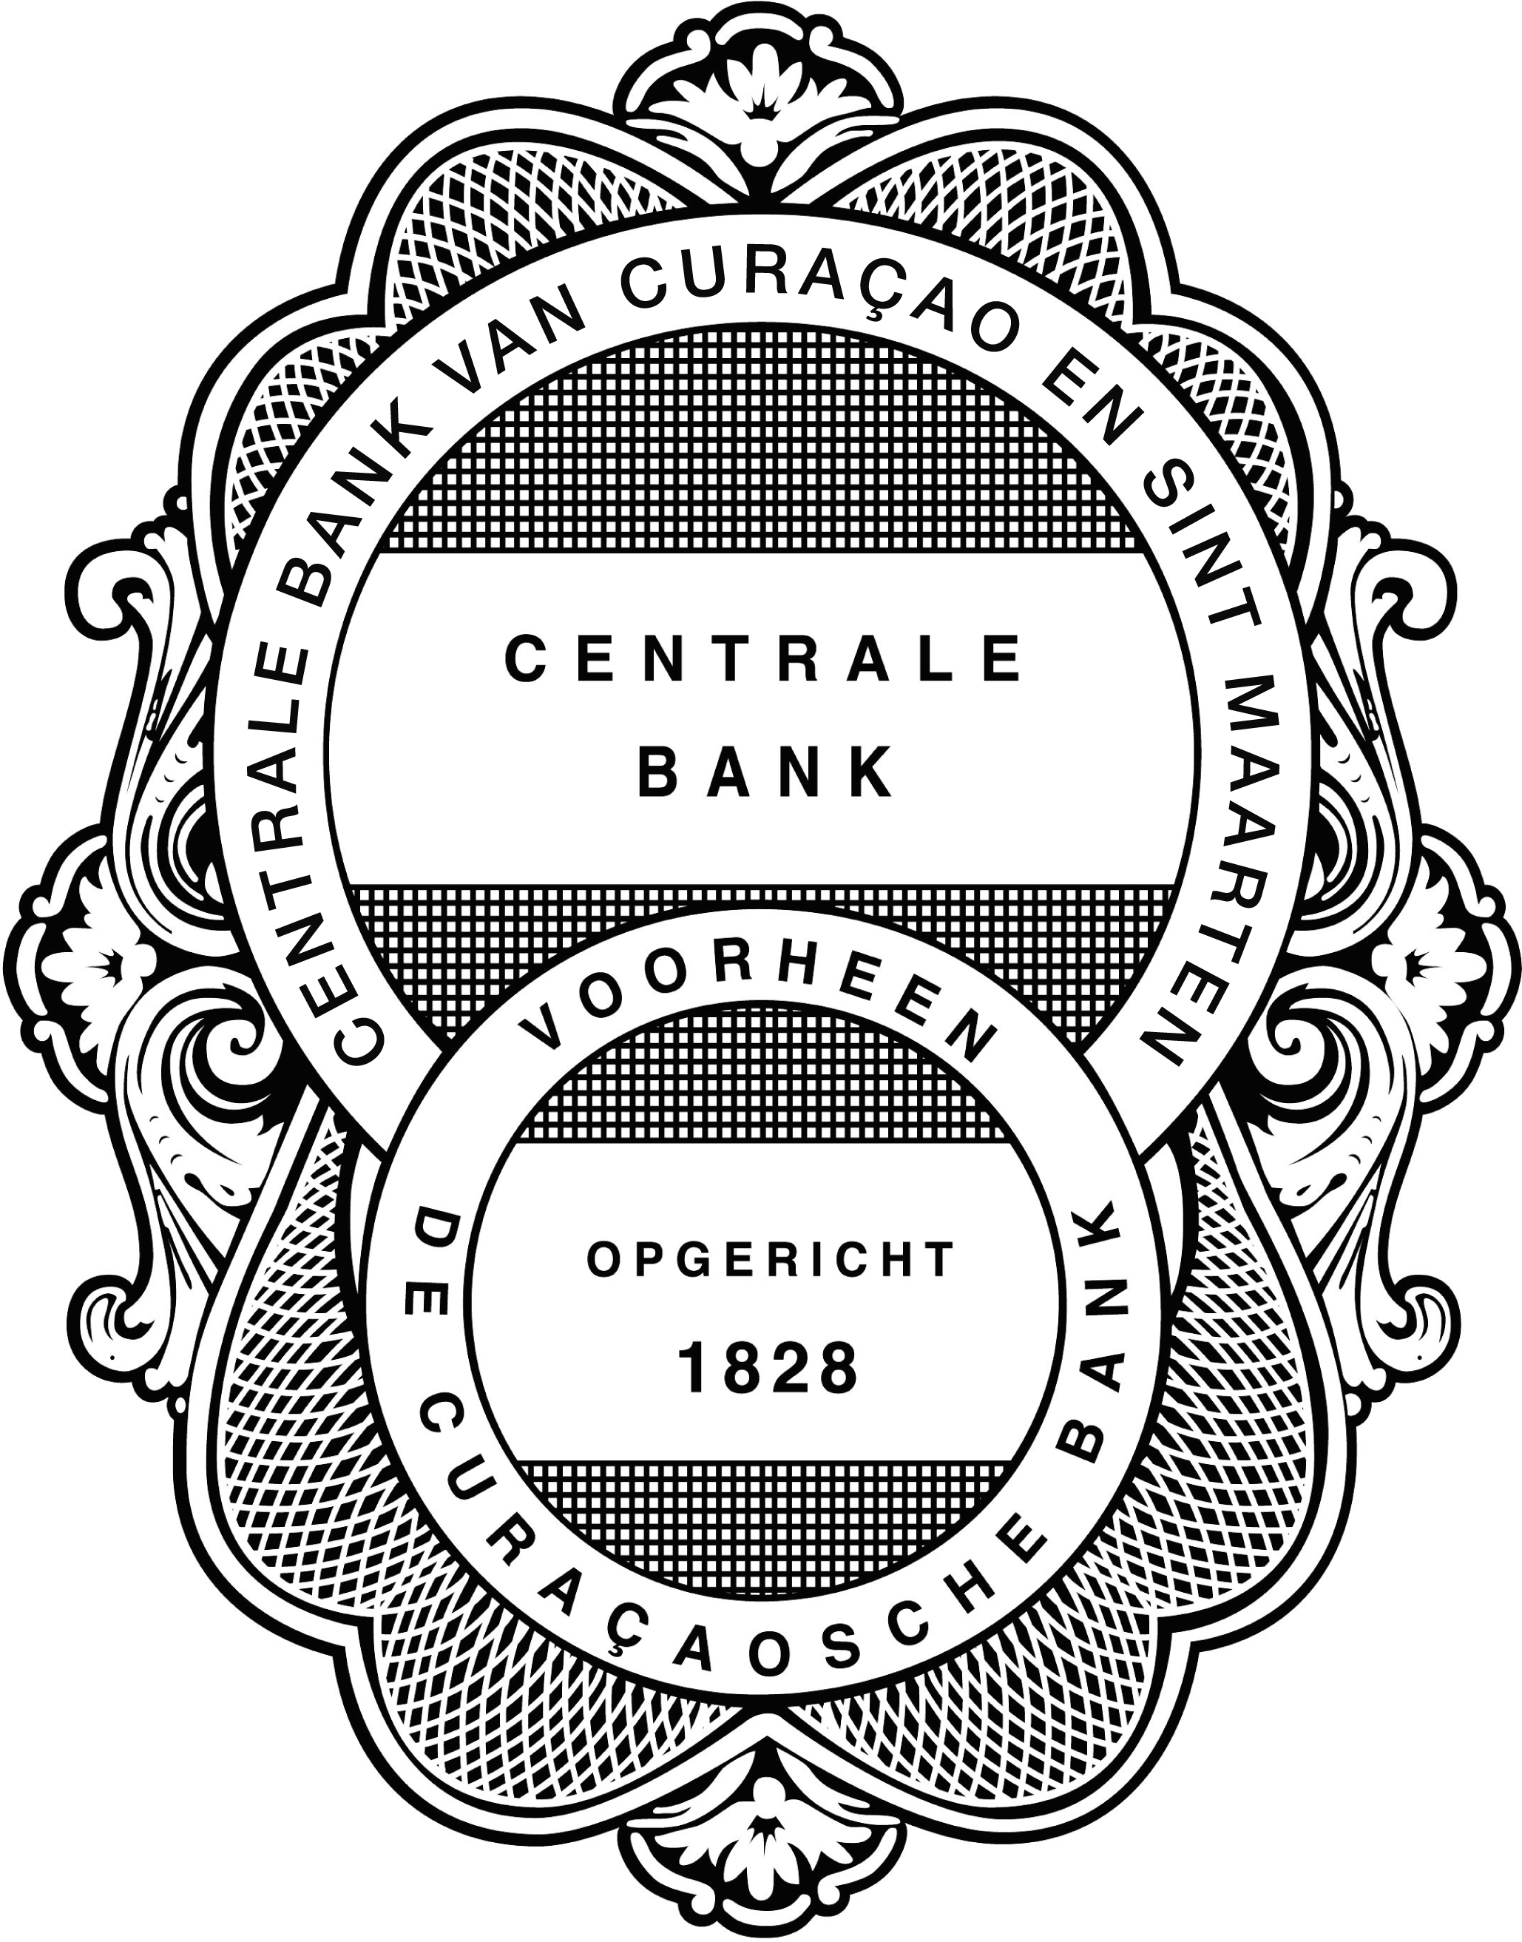
CONFIDENTIAL
REGISTRATION REQUEST FORM  For Asset Management Companies | CENTRALE BANK VAN CURAÇAO EN SINT MAARTEN (CENTRAL BANK)
 | Investment Institutions and Trust Supervision Department

Date: ……………………………………………………………………………………………………………………………………………

Name of Asset Management Company:

…………………………………………………………………………………………………………………………………………………………………

- CHECKLIST REGISTRATION FORM FOR ASSET MANAGEMENT COMPANIES

For the implementation of article 8 of the National Ordinance on the Supervision of Securities Intermediaries and Asset Management Companies (N.G. 2016, no. 79), hereafter referred to as “National Ordinance”.

This registration form guides the registrant through all the necessary documents and information required to register as an Asset Management Company, as defined in article 1 of the National Ordinance. This form must be signed by at least one managing director representing the Asset Management Company. This form will be processed after all the items listed below are received. Please indicate whether the documents and information listed have been included with the registration by checking the corresponding box:

This form completed and signed by at least one managing director of the Asset Management Company.

Copy of the license document obtained from the Central Bank

Framework of the administrative organization and internal control environment.

Information on the business operations.

Extracts of Chamber of Commerce, if applicable.

Articles of Association.

Internal and Group holdings structure.

Information on the protection of the clients’ funds and securities.

Outsourcing/ Sample agreements.

Information on Equity Capital and Solvency requirements.

Proof of payment of nonrefundable registration fee.

Supplementary information.

GENERAL INFORMATION

All information supplied in this form, including in the annexes, is confidential and should be supplied, preferably typewritten in bold letters. If a question is not applicable or is answered with a “no”, an explanation should be provided. If the information cannot be supplied in the available space, please provide the additional information with reference to the question on the registration request form. Furthermore, additional necessary documents should be attached to the registration request form with reference to the corresponding question or annex. Inadequate or inaccurate information may result in a delay in processing the registration or a rejection of the registration. If during the registration process, changes occur in the information as provided on the registration request form, the Centrale Bank van Curaçao en Sint Maarten must immediately be informed thereof in writing.

1. ASSET MANAGEMENT COMPANY INFORMATION

  - Please provide the (statutory) name of the (proposed) Asset Management Company and, if applicable, the name(s) under which the business will be conducted.

  - Please provide the following information on the (proposed) Asset Management Company:

- Address
- P.O. Box (if available)
- Telephone number(s)
- Telefax number(s)
- E-mail address
- Website
- Name, title, and e-mail address of contact person responsible for reporting to the Central Bank

- A. To which form of supervision is the (proposed) Asset Management Company currently subject to? Please check the appropriate box(es)  1.3B. Please provide the Bank with a copy of the license document obtained from the Bank | the Asset Management Company is subjected to supervision pursuant to the National Ordinance on the Supervision of Banking and Credit Institutions (N.G. 1994, no. 4) of the Central Bank.  the Asset Management Company is subjected to supervision pursuant to the National Ordinance on the Supervision of Institutional Investors and Insurance Intermediaries (N.G. 1990, no. 77) of the Central Bank.  the Asset Management Company is subjected to supervision pursuant to the National Ordinance on the Supervision of Investment Institutions and Administrators (N.G. 2002, no. 137) of the Central Bank.  the Asset Management Company is subjected to supervision pursuant to the National Ordinance on the Supervision of Trust Service Providers (N.G. 2003, no. 114) of the Central Bank.  other, please specify  ……………………………………………………………………………………………

2. DIRECTORS AND (CO-)POLICY MAKERS OF THE ASSET MANAGEMENT COMPANY

  - Please provide the names of the directors, including non-executive directors, if any, of the (proposed) Asset Management Company. Indicate if resident or non-resident of Curaçao or Sint Maarten. If (proposed) Asset Management Company has non-executive directors, please indicate who the executives and who the non-executive directors are. If the (proposed) Asset Management Company has directors being legal entities, please state the names of the natural persons (functioning as directors) of the legal entities.

  - Please provide the names of any other
(co-)policy makers of the (proposed) Asset Management Company.

  - Have the persons listed under 2.1 and 2.2 been subjected to the Bank’s integrity test?

If no, please provide the name(s) of the person(s) that has (have) not been subjected to the Bank’s integrity test.
The Personal Questionnaire(s) must also be submitted in this respect.

  - If the Asset Management Company has a two-tier Board, please provide the names of the Supervisory Board members of the (proposed) Asset Management Company. Indicate if resident or non-resident.

  - Please provide the names of the person(s) fulfilling the Compliance Officers’ function responsible for amongst other the detection and deterrence of Money Laundering & Terrorist Financing.
3 SERVICE PROVIDERS OF THE ASSET MANAGEMENT COMPANY
3A. LEGAL ADVISORS (ENGAGED SINCE ………../………./………. (MM/DD/YY))

3A.1 Please provide the following information on the Asset Management Company’s legal advisors:  - Name of Firm  - Full Address  - P.O. Box (if available)  - Country  - Telephone number(s)  - Telefax number(s)  - E-mail address  - Website | 1.………………………………………………………………  …………………………………………………………………  …………………………………………………………………  2.………………………………………………………………  ………………………………………………………………  …………………………………………………………………
3A.2 Please provide the name of the Lawyer/Attorney assigned of the Legal Advisor. | …………………………………………………………………  …………………………………………………………………
3A.3 Has the Asset Management Company changed legal advisor during the three years prior to the date of this application?  If so, provide details of the change, including the reason for it. | ………………………………………………………………  …………………………………………………………………  …………………………………………………………………  ………………………………………………………………

3B. BANKERS (ENGAGED SINCE ………../………./………. (MM/DD/YY))

Please provide the following information on the Asset Management Company’s bankers:  - Name of Institution  - Full Address  - P.O. Box (if available)  - Country  - Telephone number(s)  - Telefax number(s)  - E-mail address  - Website | 1.………………………………………………………………  …………………………………………………………………  2.………………………………………………………………  …………………………………………………………………  3.……………………………………………………………………

4. OTHER INFORMATION

4.1 Please indicate if the Asset Management Company is associated by name, function, or in any other way with other Asset Management Companies. If answered with “Yes”, please attach an annex giving all relevant details.
Yes
No

4.2 Has the Asset Management Company, any of its directors or senior officers:

a) Been licensed or registered in any jurisdiction under any law which requires licensing or registration in relation to securities business? If answered with “Yes”, please attach an annex giving all relevant details.

Yes
No

b) Been licensed, registered or otherwise authorized by law to carry on any trade, business or profession in any jurisdiction? If answered with “Yes”, please attach an annex giving all relevant details.

Yes
No

c) Been refused or restricted in any jurisdiction the right to carry on any trade, business or profession for which a specific license, registration or other authorization is required by law? If answered with “Yes”, please attach an annex giving all relevant details.

Yes
No

4.3 Administrative Organization and Internal Control

Please provide the information with regards to the framework of the Administrative Organization and Internal Control environment of the Asset Management Company. See attached guidelines in Annex 1 for the preparation of the framework of the Administrative Organization and Internal Control environment.

4.4 Business Operations

Please provide the information on the controlled and sound business operations mentioned in Annex 2.

4.5 Chamber of Commerce

Please provide the Extract from the Chamber of Commerce of the Asset Management Company
If applicable, please provide the Extract from the Chamber of Commerce of the directors of the Asset Management Company that are legal entities

If the registrant cannot submit one of the (applicable) aforementioned Extracts, the reason must be stated.

4.6 Articles of Association

Please provide the Articles of Association of the Asset Management Company
If a director of the Asset Management Company is a legal entity, please provide additionally a copy of the notarized Articles of Association and amendments thereto of the legal entity, if any.

4.7 Internal and Group structures

Please provide a copy of the internal organizational chart
Please provide a copy of the group holdings structure
Please indicate which of the companies are considered subsidiaries.

4.8 Information on the protection of the clients’ funds and securities

Please enclose documentation on the measures taken by the Asset Management Company to protect the clients’ rights in funds or securities, and to prevent the use by the Asset Management Company of those funds or securities for its own account (segregation of assets)

Documentation on the protection of the clients’ funds or securities (page …………)

4.9 Outsourcing/ Sample agreements

Please supply a copy (or copies, if more than one format is used) of agreements with third parties, where activities that are part of the business operations of the Asset Management Company have been outsourced to the third parties. Please specify below which part(s) of the business operations has (have) been outsourced. Please enclose a copy of the agreements with the application:

Agreement with regards to:…………………………………

Agreement with regards to:…………………………………

Agreement with regards to:…………………………………

Please specify/indicate if Article 27 of the National Ordinance has been observed during the outsourcing process:

4.10 Information on Equity Capital and Solvency
Please submit the certified financial statements from an external auditor to support the Asset Management Company’s compliance with the:

Equity Capital Requirements pursuant to Article 22 of the National Ordinance; and
 Solvency Requirements pursuant to Article 23 of the National Ordinance

4.11 Proof of payment of nonrefundable registration fee

Please submit a proof of payment to the Central Bank of the nonrefundable registration fee

4.12 Supplementary information
With explicit reference to the questions on the registration request form, please provide any additional information that could not be supplied on the registration request form or provide any additional comments you wish to make. Additional pages could be added.

REGISTRATION REQUEST FORM  For Asset Management Companies | CENTRALE BANK VAN CURAÇAO EN SINT MAARTEN (CENTRAL BANK)
 | Investment Institutions and Trust Supervision Department

The undersigned director(s) of the Asset Management Company declare(s) that the information provided in this registration request form, including the annexes, is true, accurate, and complete.

Name: ………………………………………………………………………………………………………………… | Signature: …………………………………………………………………………………………………………  Date: ………………………………………………………………………………………………………………………..…
Title: ……………………………………………………………………………………………………………………

Name: ………………………………………………………………………………………………………………… | Signature: …………………………………………………………………………………………………………
Title: ………………………………………………………………………………………………………………………
 | Date: ………………………………………………………………………………………………………………………

Annex 1: General guidelines for the preparation of the framework of the Administrative Organization and Internal Control environment

The administrative organization and internal controls procedures manual should contain at least the following: (Check the box next to the item if the item has been included in the plan or the manual).

Framework of the administrative organization and internal control environment

Please indicate/provide the following in the framework of the administrative organization and internal control environment:

1. How the administrative department is or will be structured and the number and
functions of the administrative personnel. (page …………)

2. Whether Management will obtain information on a periodic basis from the administrative department and the nature of the provided information. Please specify period: daily/weekly/ monthly/quarterly/yearly/other. (page …………)

3. All critical controls in the IT environment (including backup, security, retrieval, and
contingency procedures). (page …………)

4. The segregation of duties between accounting, operations, and internal audit. (page …………)

5. The activities of the internal audit function, its strength in terms of available staff, their
training and experience, to whom the internal auditors report and the type and frequency of
reports issued. Also, indicate, if applicable, whether headquarter’s or parent institution’s
internal auditors are involved in periodic on-site reviews of the Asset Management Company
and to whom their findings are reported. (page…………)

6. All relevant administrative procedures and measures of internal control in sensitive,
significant, and critical areas of operation and areas susceptible to fraud and misappropriations. (page…………)
Sensitive areas are those areas that need close monitoring because of the sensitive nature of the information that passes through that area. The information is considered sensitive due to privacy considerations with respect to clients, investors, employees, and financial institutions or because if it became known, it will likely have an adverse impact on the Asset Management Company (e.g., mailing, payroll, clients’ confidential information).

Significant areas are defined as those areas resulting in large volumes of transactions and/or large balances.

Critical areas are defined as those areas that represent the core of the business and/or represent major risks for the Asset Management Company.

Areas susceptible to fraud, misappropriations and abusive practices are areas that need to be closely controlled and supervised because of the involvement of large amount of money and the adverse impact they have on investors’ confidence in the securities market.

7. The involvement of third parties, such as external auditors and consultants (e.g. management, computer, tax, and payroll) in the operation of the Asset Management Company and the nature of the work performed by these third parties. (page …………)

Annex 2 Information on business operations (Chapter V, paragraph 4 of the National Ordinance)

Please enclose documentation on the controlled and sound conduct of business operations. This documentation should describe the policy measures that will be taken by the Asset Management Company that will safeguard a controlled and sound conduct of business at all times. Please submit the Asset Management Company’s:

1. Documentation on the systematic analysis of integrity risk. (page …………)

2. Documentation on the measures to prevent conflicts of interests between the Asset Management Company and its clients and among the Asset Management Company’s clients. (page …………)

3. Documentation on the commitment regarding the detection and deterrence of money laundering and terrorist financing (page …………)

4. Documentation on the compliance with the National Ordinance on Identification of Clients when rendering Services (N.G. 2010, no. 40) as lastly amended by (N.G.2015, no. 69) (NOIS Curaçao), the National Ordinance on the Reporting of Unusual Transactions (N.G. 2010, no.41) as lastly amended by (N.G. 2015, no 68) (NORUT Curaçao), or other provisions and guidelines regarding detection and deterrence of money laundering and terrorist financing (page …………)

5. Documentation on the measures to prevent offences or other transgressions of the law that can be committed by the Asset Management Company or its employees that could damage the confidence in the Asset Management Company or in the financial markets. (page …………)

6. Documentation on the measures to prevent damage in the confidence in the Asset Management Company or in the financial markets due to the Asset Management Company’s relation with certain (type of) clients or other parties.
(page …………)

7. Documentation on the measures to prevent the Asset Management Company or its employees from performing acts that are so contrary to generally accepted standards that these could damage the confidence in the Asset Management Company or in the financial markets (page …………)

8. Documentation on the systematic analysis of the general business risks and financial risks
(page …………)

9. Documentation on the orderly and transparent financial market processes and due care in
rendering services to clients. Particular attention should be given to the manner in which
clients can file complaints against other clients and the manner in which the complaints are
being handled by the Asset Management Company (page …………)

As amended by the National Ordinance Updating and Harmonization of the Supervision Ordinances Centrale Bank van Curaçao en Sint Maarten N.G. 2015, no. 67)
Idem as footnote 1
Idem as footnote 1
Idem as footnote 1

